Octagonal Prism
# Source: AI Source: Provided by: [Data Path: Persons Table -> ID Column: 1, Name_En Column: Motasem Essam] -> From: [ChatGPT] on [7/25/2026]
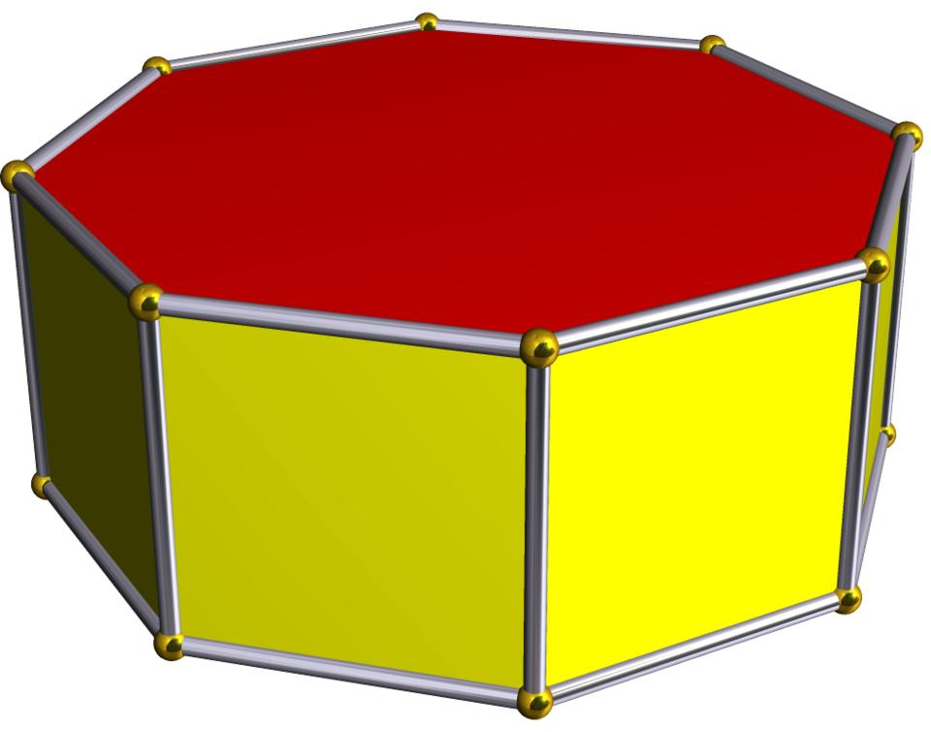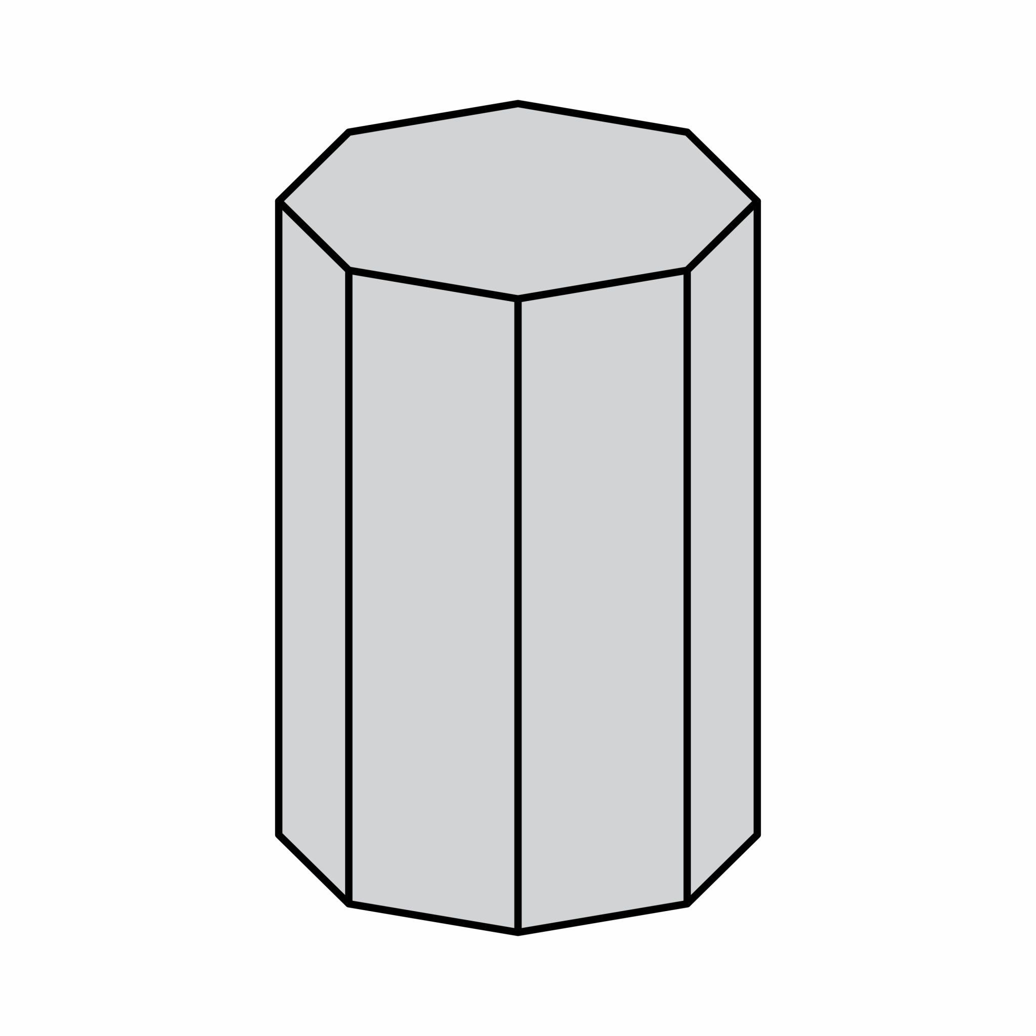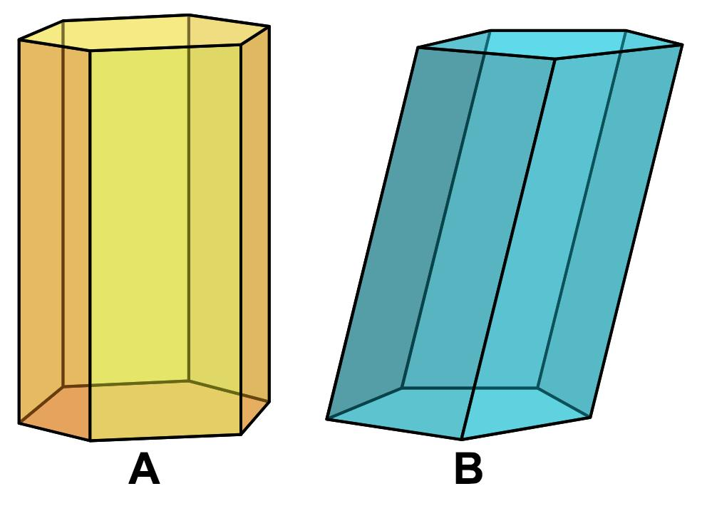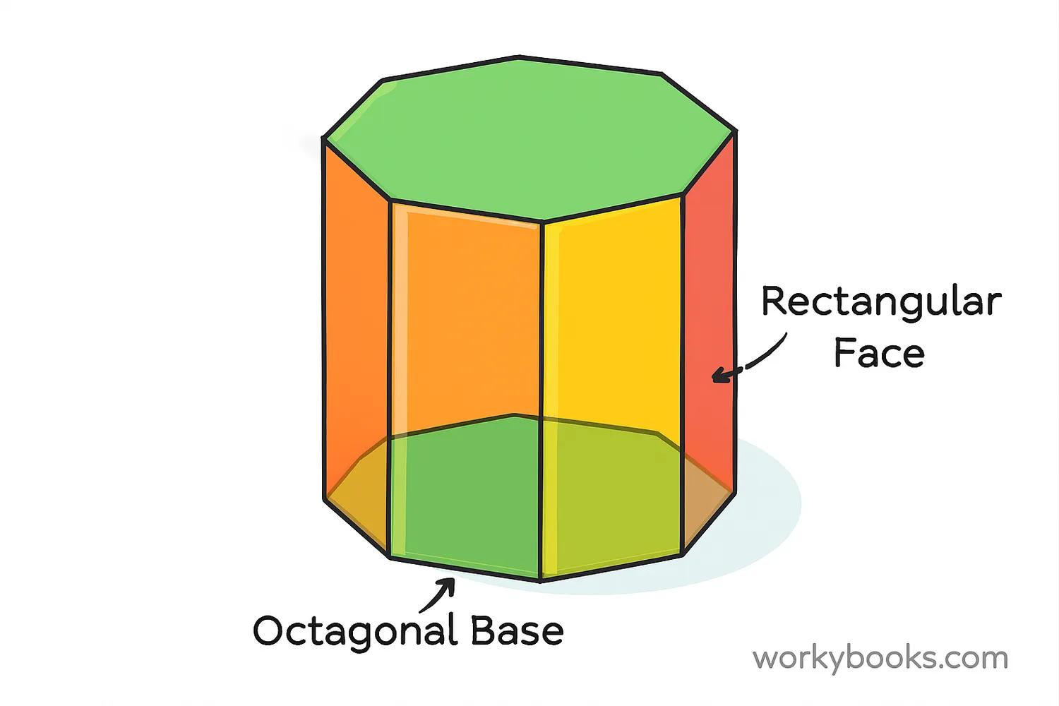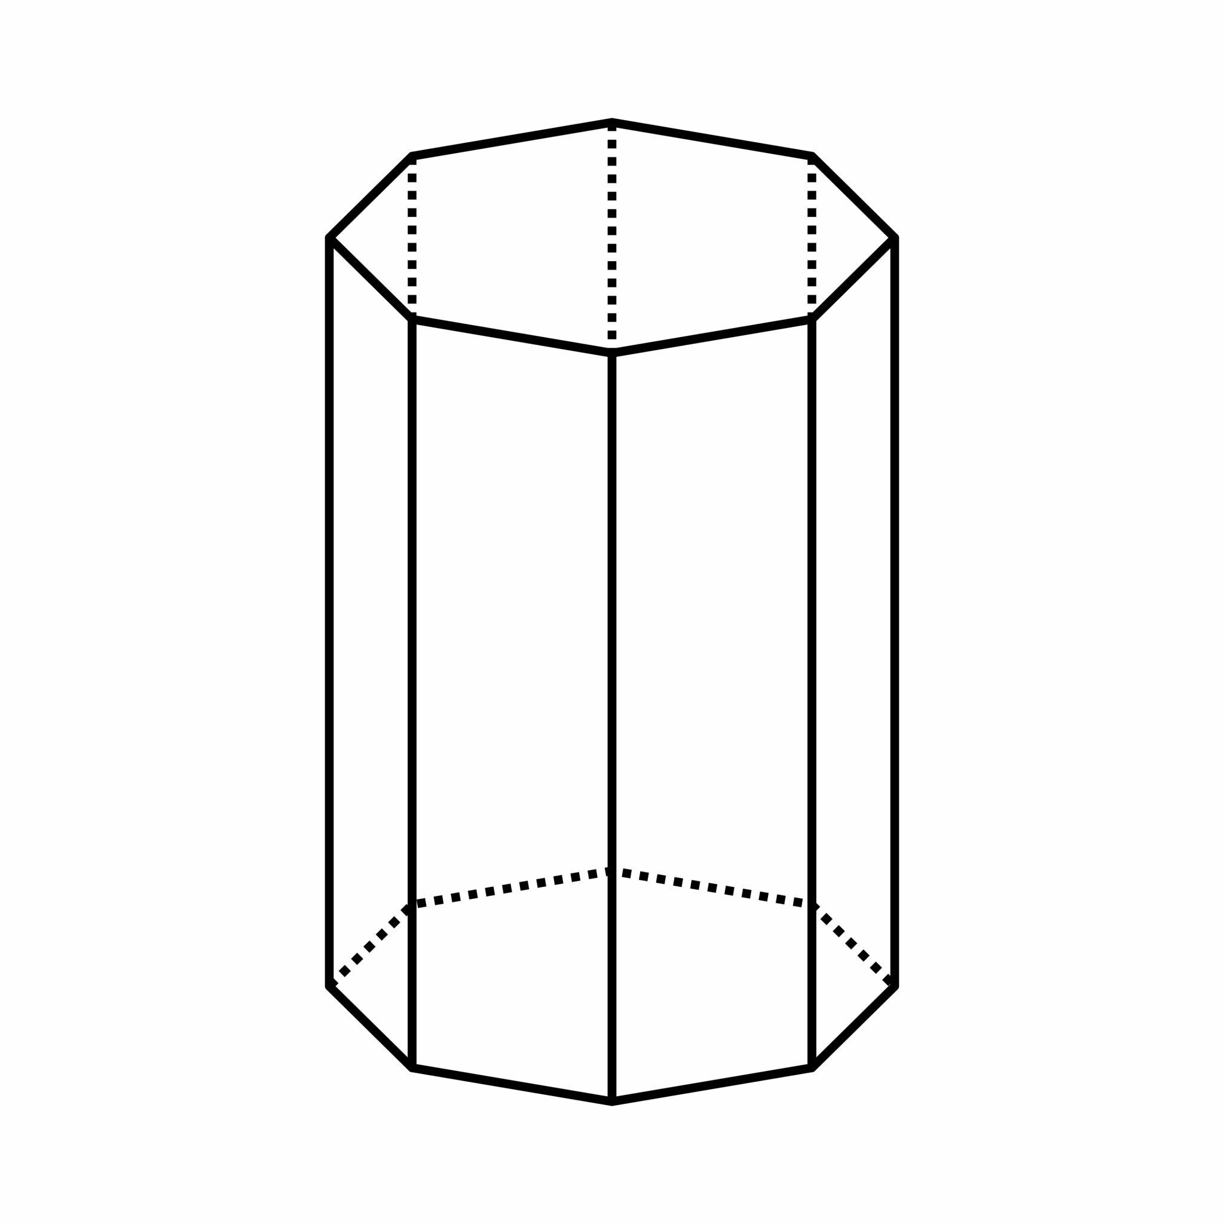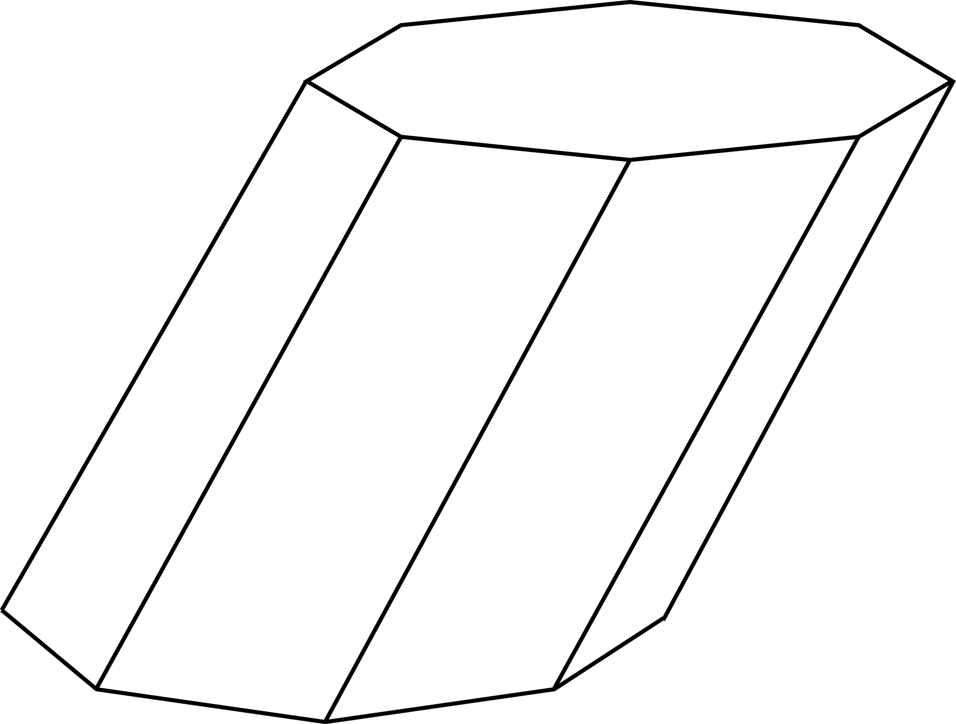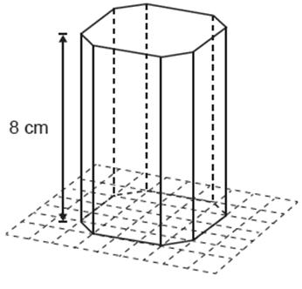

Definition
# Source: AI Source: Provided by: [Data Path: Persons Table -> ID Column: 1, Name_En Column: Motasem Essam] -> From: [ChatGPT] on [7/25/2026]
An octagonal prism is a three-dimensional polyhedron with two congruent, parallel octagonal bases connected by eight lateral faces.
Each octagonal base has eight sides and eight vertices. The eight lateral faces connect corresponding edges of the two bases, forming a closed solid.
A right octagonal prism has lateral edges perpendicular to the bases and rectangular lateral faces. An oblique octagonal prism has inclined lateral edges and parallelogram lateral faces.

Simple Definition
# Source: AI Source: Provided by: [Data Path: Persons Table -> ID Column: 1, Name_En Column: Motasem Essam] -> From: [ChatGPT] on [7/25/2026]
An octagonal prism is a solid shape with two identical octagons at opposite ends and eight side faces.

Classification Tree
# Source: AI Source: Provided by: [Data Path: Persons Table -> ID Column: 1, Name_En Column: Motasem Essam] -> From: [ChatGPT] on [7/25/2026]
Right Octagonal Prism
Lateral edges are perpendicular to the bases.
Oblique Octagonal Prism
Lateral edges are inclined to the bases.
Regular-Base Prism
The bases are regular octagons.
Irregular-Base Prism
The bases are irregular octagons.
These classifications describe different properties. For example, a prism can be both right and regular-base. A regular octagonal prism conventionally has regular octagonal bases and perpendicular lateral edges.

Key Characteristics
# Source: AI Source: Provided by: [Data Path: Persons Table -> ID Column: 1, Name_En Column: Motasem Essam] -> From: [ChatGPT] on [7/25/2026]
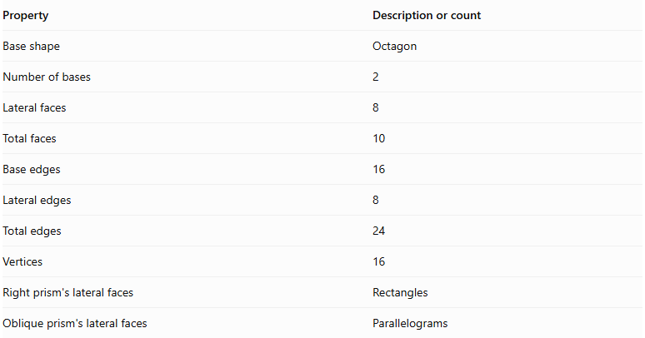
Property | Description or count
Base shape | Octagon
Number of bases | 2
Lateral faces | 8
Total faces | 10
Base edges | 16
Lateral edges | 8
Total edges | 24
Vertices | 16
Right prism's lateral faces | Rectangles
Oblique prism's lateral faces | Parallelograms

Geometric Representation
# Source: AI Source: Provided by: [Data Path: Persons Table -> ID Column: 1, Name_En Column: Motasem Essam] -> From: [ChatGPT] on [7/25/2026]
The main components of an octagonal prism are:
- Octagonal bases: The two congruent, parallel octagons.
- Lateral faces: The eight faces connecting the bases.
- Base edges: The sixteen edges around the two octagonal bases.
- Lateral edges: The eight edges joining corresponding vertices of the bases.
- Vertices: The sixteen corner points of the solid.
- Height: The perpendicular distance between the two base planes.
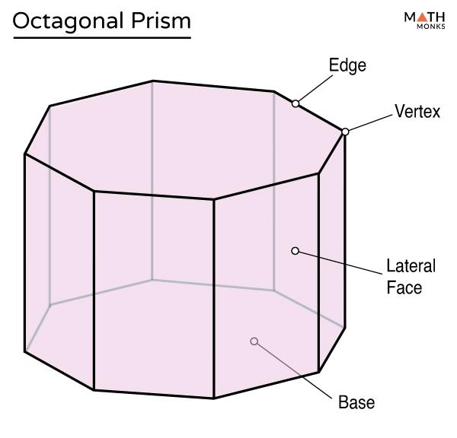

Mathematical Representations and Formulas
# Source: AI Source: Provided by: [Data Path: Persons Table -> ID Column: 1, Name_En Column: Motasem Essam] -> From: [ChatGPT] on [7/25/2026]
Let:
- $B$ = Area of one octagonal base.
- $P$ = Perimeter of one base.
- $h$ = Perpendicular height of the prism.
- $a$ = Side length of a regular octagonal base.
- $r$ = Apothem of a regular octagonal base.

A. Number of Faces, Edges, and Vertices
# Source: AI Source: Provided by: [Data Path: Persons Table -> ID Column: 1, Name_En Column: Motasem Essam] -> From: [ChatGPT] on [7/25/2026]
For a prism with an $n$-sided polygon as its base:
$$F=n+2$$
$$E=3n$$
$$V=2n$$
For an octagonal prism, $n=8$:
$$F=8+2=\boxed{10}$$
$$E=3(8)=\boxed{24}$$
$$V=2(8)=\boxed{16}$$

B. Area of a Regular Octagonal Base
# Source: AI Source: Provided by: [Data Path: Persons Table -> ID Column: 1, Name_En Column: Motasem Essam] -> From: [ChatGPT] on [7/25/2026]
For a regular octagon with side length $a$:
$$\boxed{B=2(1+\sqrt{2})a^{2}}$$
Its perimeter is:
$$\boxed{P=8a}$$
Alternatively, using the apothem:
$$\boxed{B=\frac{1}{2}Pr}$$
For a regular octagon, the apothem is:
$$\boxed{r=\frac{a}{2tan(π/8)}}$$

C. Volume
# Source: AI Source: Provided by: [Data Path: Persons Table -> ID Column: 1, Name_En Column: Motasem Essam] -> From: [ChatGPT] on [7/25/2026]
The volume of any prism is its base area multiplied by its perpendicular height:
$$\boxed{V=Bh}$$
For a regular octagonal prism:
$$\boxed{V=2(1+\sqrt{2})a^{2}h}$$

D. Lateral Surface Area
# Source: AI Source: Provided by: [Data Path: Persons Table -> ID Column: 1, Name_En Column: Motasem Essam] -> From: [ChatGPT] on [7/25/2026]
For a right octagonal prism:
$$\boxed{LSA=Ph}$$
Since for a regular octagon:
$$\boxed{LSA=8ah}$$
For an oblique prism, add the actual areas of its eight lateral parallelograms.

E. Total Surface Area
# Source: AI Source: Provided by: [Data Path: Persons Table -> ID Column: 1, Name_En Column: Motasem Essam] -> From: [ChatGPT] on [7/25/2026]
The total surface area includes the eight lateral faces and both bases:
$$\boxed{TSA=LSA+2B}$$
For a regular right octagonal prism:
$$\boxed{TSA=8ah+4(1+\sqrt{2})a^{2}}$$

Worked Examples

Example 1: Counting Faces, Edges, and Vertices
# Source: AI Source: Provided by: [Data Path: Persons Table -> ID Column: 1, Name_En Column: Motasem Essam] -> From: [ChatGPT] on [7/25/2026]
Problem: Find the number of faces, edges, and vertices of an octagonal prism.
Solution:
The base is an octagon, so $n=8$.
$$F=8+2=10$$
$$E=3(8)=24$$
$$V=2(8)=16$$
Answer: The prism has 10 faces, 24 edges, and 16 vertices.

Example 2: Calculating the Volume
# Source: AI Source: Provided by: [Data Path: Persons Table -> ID Column: 1, Name_En Column: Motasem Essam] -> From: [ChatGPT] on [7/25/2026]
Problem: An octagonal prism has a base area of $150{ cm}^{2}$ and a perpendicular height of $12 cm$. Find its volume.
Solution:
$$V=Bh$$
$$V=150×12$$
$$\boxed{V=1800{ cm}^{3}}$$

Example 3: Calculating the Area of a Regular Octagonal Base
# Source: AI Source: Provided by: [Data Path: Persons Table -> ID Column: 1, Name_En Column: Motasem Essam] -> From: [ChatGPT] on [7/25/2026]
Problem: A regular octagonal prism has a base side length of $4 cm$. Find the area of one base.
Solution:
Use the regular octagon area formula:
$$B=2(1+\sqrt{2})a^{2}$$
Substitute $a=4$:
$$B=2(1+\sqrt{2})(4)^{2}$$
$$B=32(1+\sqrt{2})$$
$$\boxed{B≈77.25{ cm}^{2}}$$

Example 4: Calculating Total Surface Area
# Source: AI Source: Provided by: [Data Path: Persons Table -> ID Column: 1, Name_En Column: Motasem Essam] -> From: [ChatGPT] on [7/25/2026]
Problem: A regular right octagonal prism has a side length of $5 cm$ and a height of $10 cm$. Find its total surface area.
Step 1: Calculate the base perimeter.
$$P=8(5)=40 cm$$
Step 2: Calculate the lateral surface area.
$$LSA=Ph=40(10)=400{ cm}^{2}$$
Step 3: Calculate the area of one base.
$$B=2(1+\sqrt{2})(5)^{2}$$
$$B≈120.71{ cm}^{2}$$
Step 4: Calculate the total surface area.
$$TSA=LSA+2B$$
$$TSA=400+2(120.71)$$
$$\boxed{TSA≈641.42{ cm}^{2}}$$

Example 5: Verifying Euler's Formula
# Source: AI Source: Provided by: [Data Path: Persons Table -> ID Column: 1, Name_En Column: Motasem Essam] -> From: [ChatGPT] on [7/25/2026]
Euler's formula for a convex polyhedron is:
$$V-E+F=2$$
For an octagonal prism:
$$16-24+10=2$$
Therefore, the octagonal prism satisfies Euler's formula.

Comparison with Related Prisms
# Source: AI Source: Provided by: [Data Path: Persons Table -> ID Column: 1, Name_En Column: Motasem Essam] -> From: [ChatGPT] on [7/25/2026]
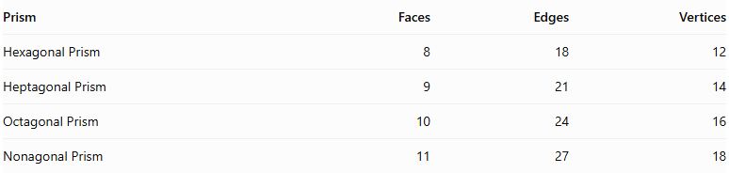
Prism | Faces | Edges | Vertices
Hexagonal Prism | 8 | 18 | 12
Heptagonal Prism | 9 | 21 | 14
Octagonal Prism | 10 | 24 | 16
Nonagonal Prism | 11 | 27 | 18
As the number of sides of the polygonal base increases by one, the prism gains one lateral face, three edges, and two vertices.

Constructing Octagonal Prism in Solid Geometry

Instruments Used
# Source: AI Source: Provided by: [Data Path: Persons Table -> ID Column: 1, Name_En Column: Motasem Essam] -> From: [ChatGPT] on [7/25/2026]
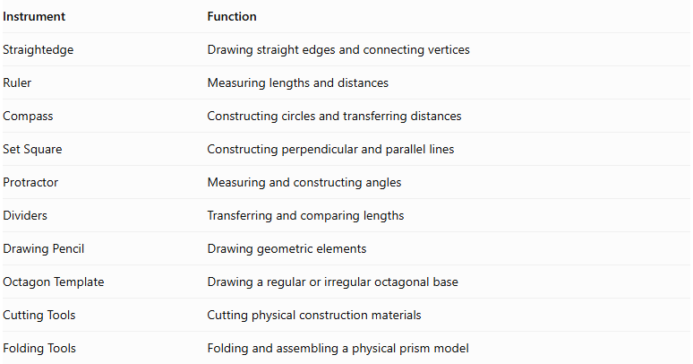
Instrument | Function
Straightedge | Drawing straight edges and connecting vertices
Ruler | Measuring lengths and distances
Compass | Constructing circles and transferring distances
Set Square | Constructing perpendicular and parallel lines
Protractor | Measuring and constructing angles
Dividers | Transferring and comparing lengths
Drawing Pencil | Drawing geometric elements
Octagon Template | Drawing a regular or irregular octagonal base
Cutting Tools | Cutting physical construction materials
Folding Tools | Folding and assembling a physical prism model

Construction Procedures

Right Octagonal Prism Construction
# Source: AI Source: Provided by: [Data Path: Persons Table -> ID Column: 1, Name_En Column: Motasem Essam] -> From: [ChatGPT] on [7/25/2026]
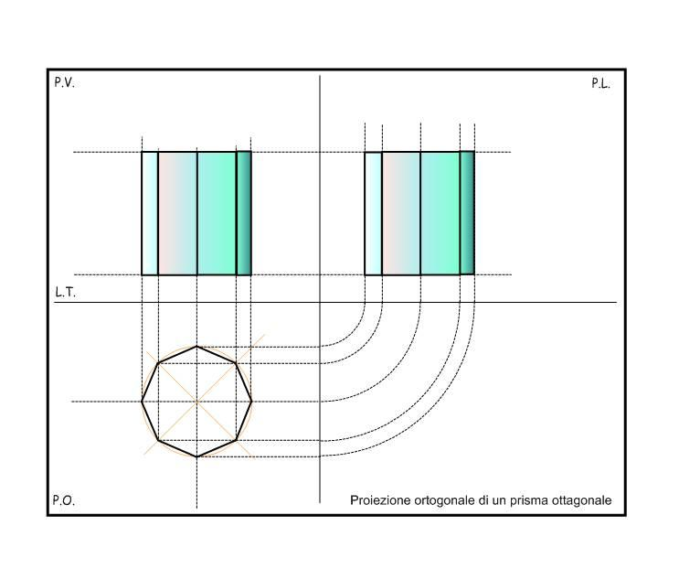
- Construct an octagonal base using geometric instruments.
- Determine the required perpendicular height.
- Construct a second octagon congruent to the first.
- Position the second base parallel to the first.
- Ensure that corresponding vertices are aligned along perpendicular lateral edges.
- Connect the corresponding vertices of both bases.
- Complete the eight rectangular lateral faces.
- Identify the visible and hidden edges to complete the geometric representation.

Oblique Octagonal Prism Construction
# Source: AI Source: Provided by: [Data Path: Persons Table -> ID Column: 1, Name_En Column: Motasem Essam] -> From: [ChatGPT] on [7/25/2026]
- Construct the first octagonal base.
- Determine the required direction and inclination of the lateral edges.
- Construct a second octagon congruent to the first in a parallel plane.
- Displace the second base in the selected oblique direction.
- Connect corresponding vertices using parallel lateral edges of equal length.
- Complete the eight parallelogram lateral faces.
- Identify the visible and hidden edges.

Net-Based Construction
# Source: AI Source: Provided by: [Data Path: Persons Table -> ID Column: 1, Name_En Column: Motasem Essam] -> From: [ChatGPT] on [7/25/2026]
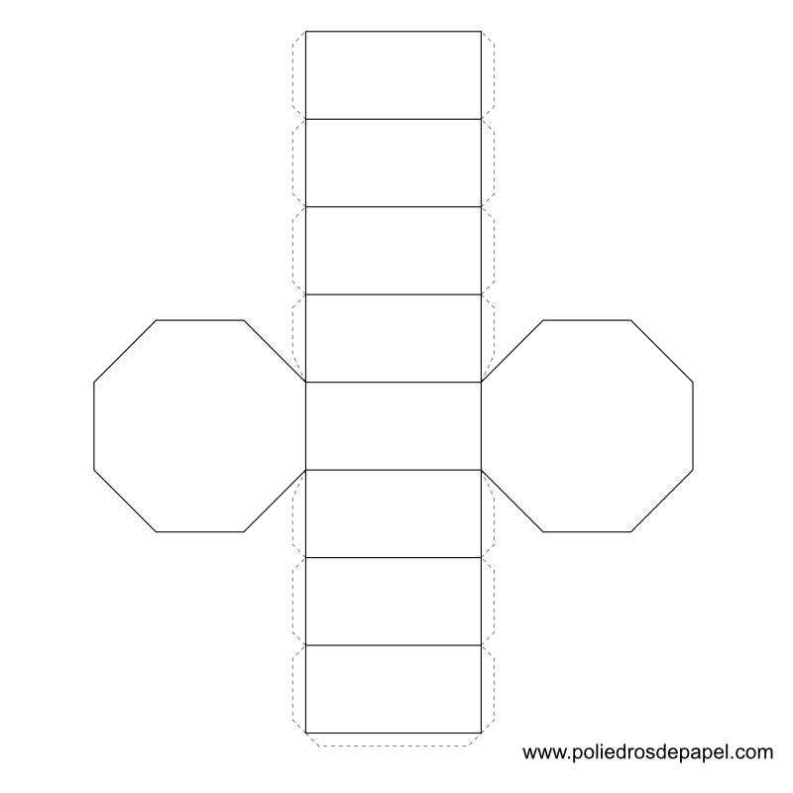
- Construct two congruent octagonal bases.
- Draw eight connected lateral faces.
- Arrange the lateral faces in a strip.
- Add the two octagonal bases in suitable positions.
- Add joining tabs if required for physical assembly.
- Cut out the net.
- Fold the lateral faces and attach the two bases.

Extrusion-Based Construction
# Source: AI Source: Provided by: [Data Path: Persons Table -> ID Column: 1, Name_En Column: Motasem Essam] -> From: [ChatGPT] on [7/25/2026]
- Construct an octagonal base.
- Establish a straight translation direction.
- Transfer the octagonal boundary along that direction.
- Construct the translated congruent octagon.
- Connect corresponding vertices.
- Complete the lateral faces to form the prism.

Applications of Octagonal Prisms
# Source: AI Source: Provided by: [Data Path: Persons Table -> ID Column: 1, Name_En Column: Motasem Essam] -> From: [ChatGPT] on [7/25/2026]
Octagonal prisms appear in several practical settings:
- Architecture: Octagonal columns, pillars, and structural components.
- Engineering: Eight-sided structural components and mechanical designs.
- Construction: Octagonal posts and building elements.
- Education: Demonstrating faces, edges, vertices, surface area, and volume.
- Computer Graphics: Representing three-dimensional polygonal objects.

Key Points
# Source: AI Source: Provided by: [Data Path: Persons Table -> ID Column: 1, Name_En Column: Motasem Essam] -> From: [ChatGPT] on [7/25/2026]
- An octagonal prism has two congruent, parallel octagonal bases.
- It has eight lateral faces and ten faces in total.
- It has 24 edges and 16 vertices.
- Its volume is $V=Bh$.
- For a right prism, its lateral surface area is $LSA=Ph$.
- Its total surface area is $TSA=LSA+2B$.
- The area of a regular octagonal base is $B=2(1+\sqrt{2})a^{2}$.
- It satisfies Euler's formula $V-E+F=2$.

Conclusion
# Source: AI Source: Provided by: [Data Path: Persons Table -> ID Column: 1, Name_En Column: Motasem Essam] -> From: [ChatGPT] on [7/25/2026]
An octagonal prism is a polyhedron with two congruent, parallel octagonal bases joined by eight lateral faces. It has ten faces, twenty-four edges, and sixteen vertices, making it a useful example of a prism with an eight-sided polygonal base.
Its volume is calculated by multiplying the base area by the perpendicular height, while its total surface area is the sum of the lateral surface area and the areas of both bases. For a regular octagonal prism, the base area can be calculated directly from its side length using:
$$B=2(1+\sqrt{2})a^{2}$$
Understanding the octagonal prism extends the general rules for polygonal prisms and helps explain how the number of sides of a base determines a solid's faces, edges, and vertices.

